**Nefisa Hassen**

**D209 task1**

**Part I: Research Question**

**A1.** **Summarize one research question.**

Is it possible to forecast patient readmission using chronic conditions, lifestyle factors, and healthcare services?

The k-nearest neighbor (KNN) classification method will be used to answer the research question.

**A2. Define the goals of the data analysis.**

The goal of this analysis is to predict the chances of a patient's readmission to the hospital by looking at chronic conditions, lifestyle factors, and healthcare service types.

**Part II: Method Justification**

**B1. Explain how the classification method you chose analyzes the selected data set.**

The Nearest Neighbor rule consistently exhibits robust performance, avoiding the need for predefined assumptions about the distributions of training examples. It operates on a training set that encompasses both positive and negative cases. When classifying a new sample, the method calculates its distance to the nearest training case, and the sign of that point dictates the sample's classification. Extending this idea, the k-NN classifier incorporates the nearest k points, determining the classification based on the majority's sign.

**B2. Summarize one assumption of the chosen classification method.**

The closer the two given points are to each other, the more related and similar they are.

**B3. List the packages or libraries you have chosen for Python or R, and justify how each item on the list supports the analysis.**

* **pandas** Used for data manipulation and analysis. It provides data structures like DataFrame for efficiently handling structured data.
* **numpy** Used for numerical operations in Python. It provides support for large, multi-dimensional arrays and matrices, along with mathematical functions to operate on these arrays.
* **scipy.stats** Part of the SciPy library, it includes statistical functions for various probability distributions and statistical tests.
* **statsmodels.api** Used for estimating and testing statistical models. It includes functions for regression analysis, hypothesis testing, and other statistical modeling tasks.
* **train_test_split**  it's used to split the dataset into training and testing sets, facilitating model evaluation.
* **KNeighborsClassifier** it provides an implementation of the k-Nearest Neighbors algorithm for classification.
* **metrics** Various metrics for evaluating machine learning models, such as accuracy, precision, recall, and F1-score.
* **roc_curve** Used for Receiver Operating Characteristic (ROC) curve analysis, a tool for evaluating the performance of classification algorithms.
* **matplotlib.pyplot** A plotting library used for creating visualizations, including charts and graphs.
* **accuracy_score, classification_report, confusion_matrix** metrics and tools for evaluating classification models, providing detailed reports and confusion matrices.
* **variance_inflation_factor** Used for detecting multicollinearity in regression analysis by calculating the variance inflation factor for each feature.
* **SelectKBest, f_classif** 
  + **SelectKBest** is a method for selecting the top k features.
  + **f_classif** is a scoring function used for feature selection based on analysis of variance (ANOVA).
* **GridSearchCV** Used for hyperparameter tuning through an exhaustive search over specified parameter values for an estimator, helping to find the best parameters for a model.

**Part III: Data Preparation**

**C1. Describe one data preprocessing goal relevant to the classification method from part A1**.

One key objective in processing the data pertinent to my research question is identifying and addressing outliers. Outliers can exert a substantial impact on the dataset, underscoring the necessity for a thorough assessment and appropriate treatment of the data. For my analysis, I used medical data and applied the **std()** function to assess outliers across all columns. Notably, outliers were detected in variables such as TotalCharge, Additional_charges, VitD_levels, and Initial_days. To address the outliers in these four columns, the z-score method was utilized for treatment.

**C2. Identify the initial data set variables that you will use to perform the analysis for the classification question from part A1 and classify *each* variable as numeric or categorical.**

**#Numeric variables**

Initial_days float64

TotalCharge float64

Additional_charges float64

VitD_levels float64

Doc_visits int64

Full_meals_eaten int64

vitD_supp int64

**#catagorial variables**

ReAdmis object

Soft_drink object

Initial_admin object

HighBlood object

Stroke object

Complication_risk object

Overweight object

Arthritis object

Diabetes object

Hyperlipidemia object

BackPain object

Anxiety object

Allergic_rhinitis object

Reflux_esophagitis object

Asthma object

Services object

**C3. Explain each of the steps used to prepare the data for the analysis. Identify the code segment for each step.**

The analysis is based on the medical data file. Upon importing the data, a thorough check for missing values was conducted, and there is no missing data entries across all columns. The **std()** function was used to assess outliers, and outliers were identified on variables such as TotalCharge, Additional_charges, VitD_levels, and Initial_days. These outliers were then treated using the z-score method.

Dummy variables were generated to convert categorical variables into numeric values. Additionally, one-hot encoding was applied to represent categorical variables with more than two options, such as 'Services,' 'Complication_risk,' and 'Initial_admin.'

Certain columns deemed irrelevant to answering the research question were removed. These include 'CaseOrder,' 'Customer_id,' 'Interaction,' 'UID,' 'City,' 'State,' 'County,' 'Zip,' 'Lat,' 'Lng,' 'Population,' 'Area,' and 'TimeZone.'

Using the selectKBest function the variables that are most significant were extracted. In addition, using the VIF function, multicollinearity among the variables was assessed and treated. Lastly, StandardScaler() function was used to scale and transform the data .

**import** pandas **as** pd

2

**import** numpy **as** np

3

**from** scipy **import** stats

4

**import** statsmodels.api **as** sm

5

**from** sklearn.model_selection **import** train_test_split

6

**from** sklearn.neighbors **import** KNeighborsClassifier

7

**from** sklearn **import** metrics

8

**from** sklearn.metrics **import** roc_curve,auc

9

**import** matplotlib.pyplot **as** plt

10

**from** sklearn.feature_selection **import** f_classif

11

**from** sklearn.metrics **import** accuracy_score, classification_report, confusion_matrix

12

**from** sklearn.preprocessing **import** StandardScaler

13

**from** statsmodels.stats.outliers_influence **import** variance_inflation_factor

14

**from** sklearn.feature_selection **import** SelectKBest, f_classif

15

**from** sklearn.model_selection **import** GridSearchCV

16

**import** matplotlib.pyplot **as** plt

17

**from** sklearn.metrics **import** roc_curve, auc

18

**from** sklearn **import** metrics

19

**import** matplotlib.pyplot **as** plt

20

**import** seaborn **as** sns

In [2]:

1

med_data **=** pd.read_csv('medical_clean.csv') *#importaing the data*

In [3]:

1

med_data.columns *#looking at the varialbles*

Out[3]:

Index(['CaseOrder', 'Customer_id', 'Interaction', 'UID', 'City', 'State',  
 'County', 'Zip', 'Lat', 'Lng', 'Population', 'Area', 'TimeZone', 'Job',  
 'Children', 'Age', 'Income', 'Marital', 'Gender', 'ReAdmis',  
 'VitD_levels', 'Doc_visits', 'Full_meals_eaten', 'vitD_supp',  
 'Soft_drink', 'Initial_admin', 'HighBlood', 'Stroke',  
 'Complication_risk', 'Overweight', 'Arthritis', 'Diabetes',  
 'Hyperlipidemia', 'BackPain', 'Anxiety', 'Allergic_rhinitis',  
 'Reflux_esophagitis', 'Asthma', 'Services', 'Initial_days',  
 'TotalCharge', 'Additional_charges', 'Item1', 'Item2', 'Item3', 'Item4',  
 'Item5', 'Item6', 'Item7', 'Item8'],  
 dtype='object')

In [4]:

1

*#deleting the columns that are irrelevant to answering the research question.*

In [5]:

1

med_data **=** med_data.drop(columns**=**['CaseOrder', 'Customer_id', 'Interaction', 'UID','Job', 'Children', 'Age', 'Income', 'Marital', 'Gender', 'City', 'State',

2

'County', 'Zip', 'Lat', 'Lng','Population', 'Area', 'TimeZone' , 'Item1', 'Item2', 'Item3', 'Item4',

3

'Item5', 'Item6', 'Item7', 'Item8' ])

In [6]:

1

med_data.columns *#checking to bee the columns are deleted*

Out[6]:

Index(['ReAdmis', 'VitD_levels', 'Doc_visits', 'Full_meals_eaten', 'vitD_supp',  
 'Soft_drink', 'Initial_admin', 'HighBlood', 'Stroke',  
 'Complication_risk', 'Overweight', 'Arthritis', 'Diabetes',  
 'Hyperlipidemia', 'BackPain', 'Anxiety', 'Allergic_rhinitis',  
 'Reflux_esophagitis', 'Asthma', 'Services', 'Initial_days',  
 'TotalCharge', 'Additional_charges'],  
 dtype='object')

In [7]:

1

med_data.dtypes *#looking at data types for each variables*

Out[7]:

ReAdmis object  
VitD_levels float64  
Doc_visits int64  
Full_meals_eaten int64  
vitD_supp int64  
Soft_drink object  
Initial_admin object  
HighBlood object  
Stroke object  
Complication_risk object  
Overweight object  
Arthritis object  
Diabetes object  
Hyperlipidemia object  
BackPain object  
Anxiety object  
Allergic_rhinitis object  
Reflux_esophagitis object  
Asthma object  
Services object  
Initial_days float64  
TotalCharge float64  
Additional_charges float64  
dtype: object

In [8]:

1

med_data.isnull().sum() *# cheking for missing data*

Out[8]:

ReAdmis 0  
VitD_levels 0  
Doc_visits 0  
Full_meals_eaten 0  
vitD_supp 0  
Soft_drink 0  
Initial_admin 0  
HighBlood 0  
Stroke 0  
Complication_risk 0  
Overweight 0  
Arthritis 0  
Diabetes 0  
Hyperlipidemia 0  
BackPain 0  
Anxiety 0  
Allergic_rhinitis 0  
Reflux_esophagitis 0  
Asthma 0  
Services 0  
Initial_days 0  
TotalCharge 0  
Additional_charges 0  
dtype: int64

In [9]:

1

*#creating dummy variables*

In [10]:

1

categorical_columns **=** [

2

'ReAdmis', 'VitD_levels', 'Doc_visits', 'Full_meals_eaten', 'vitD_supp',

3

'Soft_drink', 'HighBlood', 'Stroke', 'Overweight', 'Arthritis', 'Diabetes',

4

'Hyperlipidemia', 'BackPain', 'Anxiety', 'Allergic_rhinitis',

5

'Reflux_esophagitis', 'Asthma'

6

]

7

8

**for** column **in** categorical_columns:

9

med_data[column] **=** med_data[column].astype('category').cat.codes

In [11]:

1

*#one hot encoding for catagorical variables that have more than 2 options*

In [12]:

1

med_data **=** pd.get_dummies(med_data, columns**=**['Services','Complication_risk','Initial_admin'], drop_first**=True**)

In [13]:

1

*# checking for outliers.*

2

med_data.std()

Out[13]:

ReAdmis 0.481983  
VitD_levels 2878.750357  
Doc_visits 1.045734  
Full_meals_eaten 1.008117  
vitD_supp 0.628505  
Soft_drink 0.437279  
HighBlood 0.491674  
Stroke 0.399494  
Overweight 0.454062  
Arthritis 0.479258  
Diabetes 0.445930  
Hyperlipidemia 0.472777  
BackPain 0.492112  
Anxiety 0.467076  
Allergic_rhinitis 0.488681  
Reflux_esophagitis 0.492486  
Asthma 0.453460  
Initial_days 26.309341  
TotalCharge 2180.393838  
Additional_charges 6542.601544  
Services_CT Scan 0.327879  
Services_Intravenous 0.463738  
Services_MRI 0.191206  
Complication_risk_Low 0.409097  
Complication_risk_Medium 0.497687  
Initial_admin_Emergency Admission 0.499989  
Initial_admin_Observation Admission 0.429276  
dtype: float64

In [14]:

1

*#treating outliers with zscore method.*

In [15]:

1

med_data ['TotalCharge_z']**=**stats.zscore(med_data['TotalCharge'])

In [16]:

1

med_data_outliers_TotalCharge **=** med_data.query('TotalCharge_z > 3 | TotalCharge_z< -3')

In [17]:

1

med_data ['Additional_charges_z']**=**stats.zscore(med_data['Additional_charges'])

In [18]:

1

med_data_outliers_Additional_charges **=** med_data.query('Additional_charges_z > 3 | Additional_charges_z< -3')

In [19]:

1

med_data ['Initial_days_z'] **=** stats.zscore(med_data['Initial_days'])

In [20]:

1

med_data_outliers_Initial_days **=** med_data.query('Initial_days_z > 3 | Initial_days_z< -3')

In [21]:

1

med_data ['VitD_levels_z'] **=** stats.zscore(med_data['VitD_levels'])

In [22]:

1

med_data_outliers_VitD_levels **=** med_data.query('VitD_levels_z > 3 | VitD_levels_z< -3')

In [23]:

1

med_data.std() *# checking to see if outliers were treated.*

Out[23]:

ReAdmis 0.481983  
VitD_levels 2878.750357  
Doc_visits 1.045734  
Full_meals_eaten 1.008117  
vitD_supp 0.628505  
Soft_drink 0.437279  
HighBlood 0.491674  
Stroke 0.399494  
Overweight 0.454062  
Arthritis 0.479258  
Diabetes 0.445930  
Hyperlipidemia 0.472777  
BackPain 0.492112  
Anxiety 0.467076  
Allergic_rhinitis 0.488681  
Reflux_esophagitis 0.492486  
Asthma 0.453460  
Initial_days 26.309341  
TotalCharge 2180.393838  
Additional_charges 6542.601544  
Services_CT Scan 0.327879  
Services_Intravenous 0.463738  
Services_MRI 0.191206  
Complication_risk_Low 0.409097  
Complication_risk_Medium 0.497687  
Initial_admin_Emergency Admission 0.499989  
Initial_admin_Observation Admission 0.429276  
TotalCharge_z 1.000050  
Additional_charges_z 1.000050  
Initial_days_z 1.000050  
VitD_levels_z 1.000050  
dtype: float64

In [24]:

1

med_data **=** med_data.astype(int)

In [25]:

1

med_data['VitD_levels'].describe()

Out[25]:

count 10000.000000  
mean 4985.993300  
std 2878.750357  
min 0.000000  
25% 2493.750000  
50% 4984.500000  
75% 7478.250000  
max 9975.000000  
Name: VitD_levels, dtype: float64

In [26]:

1

med_data['Doc_visits'].describe()

Out[26]:

count 10000.000000  
mean 4.012200  
std 1.045734  
min 0.000000  
25% 3.000000  
50% 4.000000  
75% 5.000000  
max 8.000000  
Name: Doc_visits, dtype: float64

In [27]:

1

med_data['Full_meals_eaten'].describe()

Out[27]:

count 10000.000000  
mean 1.001400  
std 1.008117  
min 0.000000  
25% 0.000000  
50% 1.000000  
75% 2.000000  
max 7.000000  
Name: Full_meals_eaten, dtype: float64

In [28]:

1

med_data['vitD_supp'].value_counts()

Out[28]:

vitD_supp  
0 6702  
1 2684  
2 544  
3 64  
4 5  
5 1  
Name: count, dtype: int64

In [29]:

1

med_data['Initial_admin_Emergency Admission'].value_counts()

Out[29]:

Initial_admin_Emergency Admission  
1 5060  
0 4940  
Name: count, dtype: int64

In [30]:

1

med_data['Initial_admin_Observation Admission'].value_counts()

Out[30]:

Initial_admin_Observation Admission  
0 7564  
1 2436  
Name: count, dtype: int64

In [31]:

1

med_data['Complication_risk_Low'].value_counts()

Out[31]:

Complication_risk_Low  
0 7875  
1 2125  
Name: count, dtype: int64

In [32]:

1

med_data['Complication_risk_Medium'].value_counts()

Out[32]:

Complication_risk_Medium  
0 5483  
1 4517  
Name: count, dtype: int64

In [33]:

1

med_data['Services_CT Scan'].value_counts()

Out[33]:

Services_CT Scan  
0 8775  
1 1225  
Name: count, dtype: int64

In [34]:

1

med_data['Services_Intravenous'].value_counts()

Out[34]:

Services_Intravenous  
0 6870  
1 3130  
Name: count, dtype: int64

In [35]:

1

med_data['Services_MRI'].value_counts()

Out[35]:

Services_MRI  
0 9620  
1 380  
Name: count, dtype: int64

In [36]:

1

med_data['Overweight'].value_counts()

Out[36]:

Overweight  
1 7094  
0 2906  
Name: count, dtype: int64

In [37]:

1

med_data['Arthritis'].value_counts()

Out[37]:

Arthritis  
0 6426  
1 3574  
Name: count, dtype: int64

In [38]:

1

med_data['Diabetes'].value_counts()

Out[38]:

Diabetes  
0 7262  
1 2738  
Name: count, dtype: int64

In [39]:

1

med_data['Hyperlipidemia'].value_counts()

Out[39]:

Hyperlipidemia  
0 6628  
1 3372  
Name: count, dtype: int64

In [40]:

1

med_data['BackPain'].value_counts()

Out[40]:

BackPain  
0 5886  
1 4114  
Name: count, dtype: int64

In [41]:

1

med_data['Anxiety'].value_counts()

Out[41]:

Anxiety  
0 6785  
1 3215  
Name: count, dtype: int64

In [42]:

1

med_data['Allergic_rhinitis'].value_counts()

Out[42]:

Allergic_rhinitis  
0 6059  
1 3941  
Name: count, dtype: int64

In [43]:

1

med_data['Reflux_esophagitis'].value_counts()

Out[43]:

Reflux_esophagitis  
0 5865  
1 4135  
Name: count, dtype: int64

In [44]:

1

med_data['Asthma'].value_counts()

Out[44]:

Asthma  
0 7107  
1 2893  
Name: count, dtype: int64

In [45]:

1

med_data['TotalCharge'].describe()

Out[45]:

count 10000.000000  
mean 5311.673500  
std 2180.391406  
min 1938.000000  
25% 3179.000000  
50% 5213.500000  
75% 7459.250000  
max 9180.000000  
Name: TotalCharge, dtype: float64

In [46]:

1

med_data['Additional_charges'].describe()

Out[46]:

count 10000.000000  
mean 12934.032300  
std 6542.600277  
min 3125.000000  
25% 7985.750000  
50% 11573.500000  
75% 15626.000000  
max 30566.000000  
Name: Additional_charges, dtype: float64

In [47]:

1

med_data['Asthma'].value_counts()

Out[47]:

Asthma  
0 7107  
1 2893  
Name: count, dtype: int64

In [48]:

1

*#Describtibve ananlysis*

2

med_data.describe()

Out[48]:

|  |  |  |  |  |  |  |  |  |  |  |  |  |  |  |  |  |  |  |  |  |  |
| --- | --- | --- | --- | --- | --- | --- | --- | --- | --- | --- | --- | --- | --- | --- | --- | --- | --- | --- | --- | --- | --- |
|  | **ReAdmis** | **VitD_levels** | **Doc_visits** | **Full_meals_eaten** | **vitD_supp** | **Soft_drink** | **HighBlood** | **Stroke** | **Overweight** | **Arthritis** | **...** | **Services_Intravenous** | **Services_MRI** | **Complication_risk_Low** | **Complication_risk_Medium** | **Initial_admin_Emergency Admission** | **Initial_admin_Observation Admission** | **TotalCharge_z** | **Additional_charges_z** | **Initial_days_z** | **VitD_levels_z** |
| **count** | 10000.000000 | 10000.000000 | 10000.000000 | 10000.000000 | 10000.000000 | 10000.000000 | 10000.000000 | 10000.000000 | 10000.000000 | 10000.000000 | ... | 10000.000000 | 10000.000000 | 10000.000000 | 10000.000000 | 10000.000000 | 10000.000000 | 10000.000000 | 10000.000000 | 10000.000000 | 10000.000000 |
| **mean** | 0.366900 | 4985.993300 | 4.012200 | 1.001400 | 0.398900 | 0.257500 | 0.409000 | 0.199300 | 0.709400 | 0.357400 | ... | 0.313000 | 0.038000 | 0.212500 | 0.451700 | 0.506000 | 0.243600 | 0.010100 | 0.098600 | -0.000800 | 0.000100 |
| **std** | 0.481983 | 2878.750357 | 1.045734 | 1.008117 | 0.628505 | 0.437279 | 0.491674 | 0.399494 | 0.454062 | 0.479258 | ... | 0.463738 | 0.191206 | 0.409097 | 0.497687 | 0.499989 | 0.429276 | 0.690974 | 0.704079 | 0.717113 | 0.650032 |
| **min** | 0.000000 | 0.000000 | 0.000000 | 0.000000 | 0.000000 | 0.000000 | 0.000000 | 0.000000 | 0.000000 | 0.000000 | ... | 0.000000 | 0.000000 | 0.000000 | 0.000000 | 0.000000 | 0.000000 | -1.000000 | -1.000000 | -1.000000 | -1.000000 |
| **25%** | 0.000000 | 2493.750000 | 3.000000 | 0.000000 | 0.000000 | 0.000000 | 0.000000 | 0.000000 | 0.000000 | 0.000000 | ... | 0.000000 | 0.000000 | 0.000000 | 0.000000 | 0.000000 | 0.000000 | 0.000000 | 0.000000 | -1.000000 | 0.000000 |
| **50%** | 0.000000 | 4984.500000 | 4.000000 | 1.000000 | 0.000000 | 0.000000 | 0.000000 | 0.000000 | 1.000000 | 0.000000 | ... | 0.000000 | 0.000000 | 0.000000 | 0.000000 | 1.000000 | 0.000000 | 0.000000 | 0.000000 | 0.000000 | 0.000000 |
| **75%** | 1.000000 | 7478.250000 | 5.000000 | 2.000000 | 1.000000 | 1.000000 | 1.000000 | 0.000000 | 1.000000 | 1.000000 | ... | 1.000000 | 0.000000 | 0.000000 | 1.000000 | 1.000000 | 0.000000 | 0.000000 | 0.000000 | 1.000000 | 0.000000 |
| **max** | 1.000000 | 9975.000000 | 8.000000 | 7.000000 | 5.000000 | 1.000000 | 1.000000 | 1.000000 | 1.000000 | 1.000000 | ... | 1.000000 | 1.000000 | 1.000000 | 1.000000 | 1.000000 | 1.000000 | 1.000000 | 2.000000 | 1.000000 | 1.000000 |

8 rows × 31 columns

In [49]

1

**#Histograms of all Variables**

med_data.hist(bins**=**20, figsize**=**(15, 10))

2

plt.suptitle('Histograms of all Variables', x**=**0.5, y**=**0.92, fontsize**=**16)

3

plt.show()

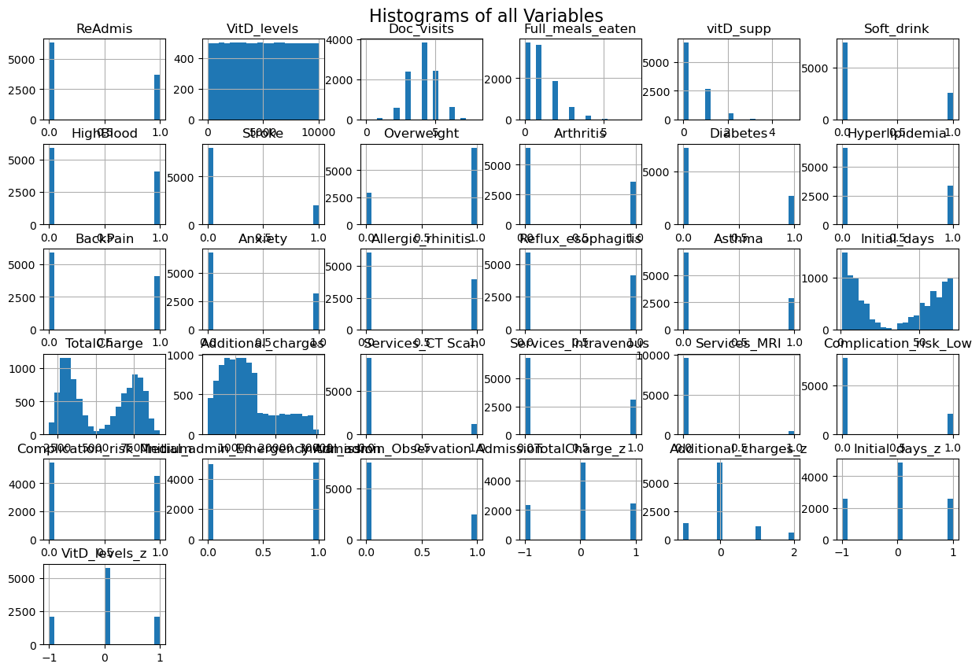

In [50]:

1

**# Heatmap of all the variables**

correlation_matrix **=** med_data.corr()

In [51]:

1

plt.figure(figsize**=**(15, 12))

2

sns.heatmap(correlation_matrix, cmap**=**'coolwarm', annot**=True**, fmt**=**".2f", linewidths**=**.5)

3

plt.title('Heatmap of Correlation Matrix fot all the Variables', fontsize**=**16)

4

plt.show()

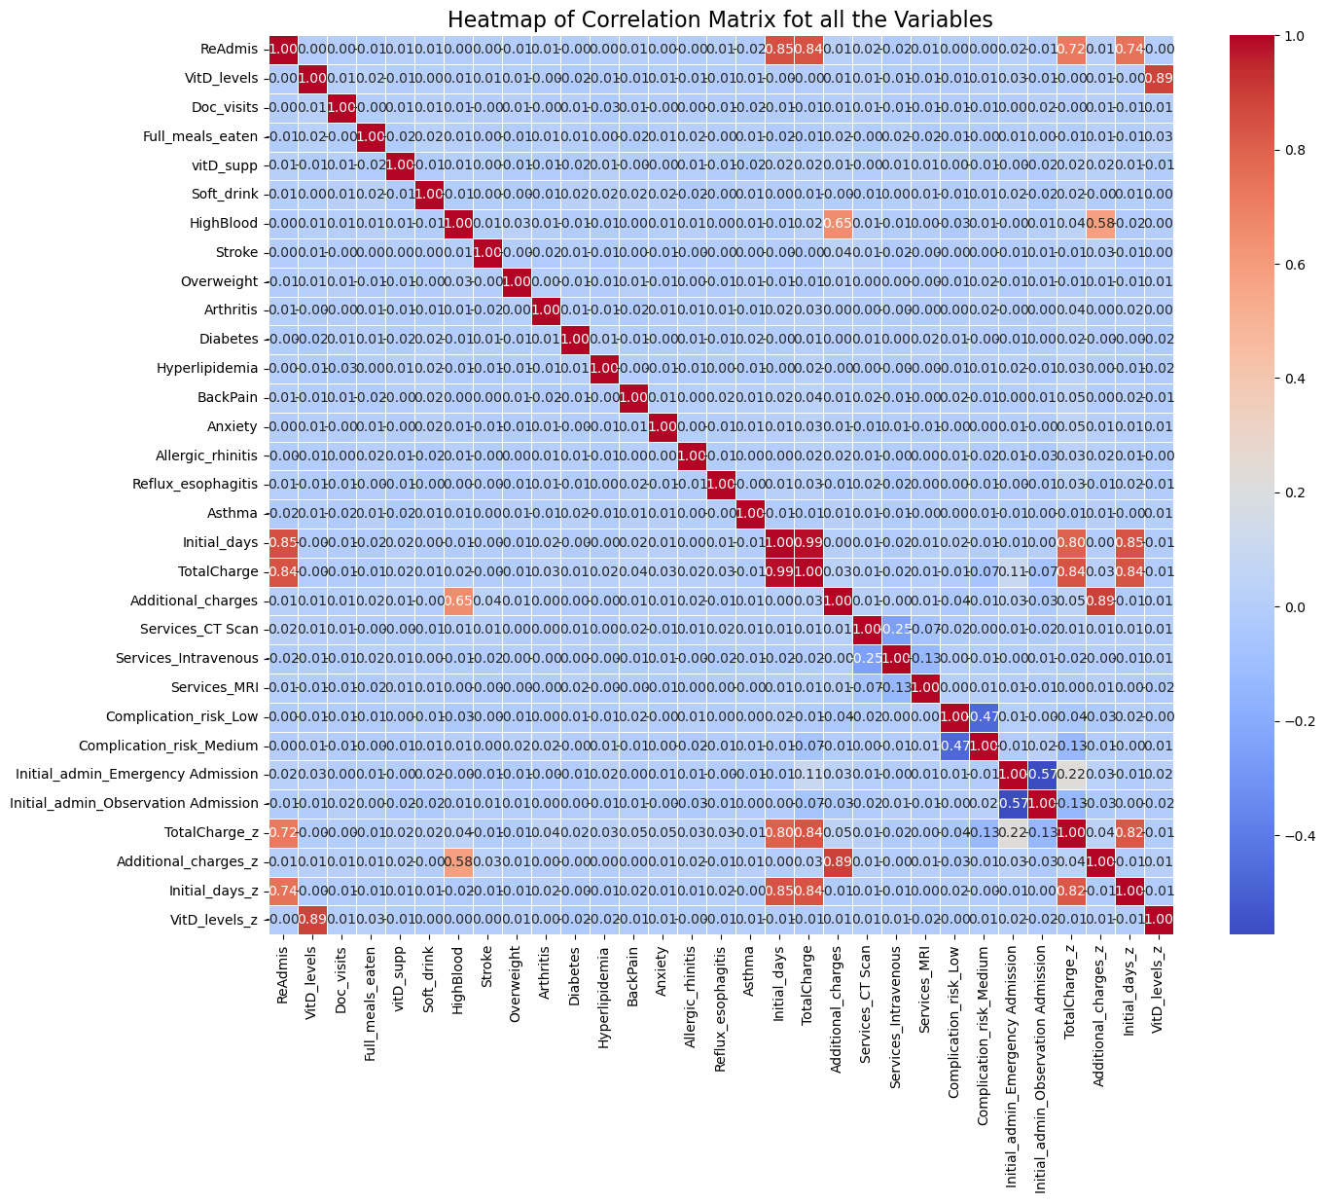

In [52]:

1

*#create a data frame with all training data except the target column*

2

X **=** med_data.drop(columns **=** ['ReAdmis'])

In [53]:

1

y **=** med_data['ReAdmis']

In [54]:

1

skbest **=** SelectKBest(score_func**=**f_classif, k**=**'all')

2

3

X_new**=**skbest.fit_transform(X,y)

4

5

X_new.shape

Out[54]:

(10000, 30)

In [55]:

1

p_values **=** pd.DataFrame({'Feature': X.columns, 'p_value': skbest.pvalues_}).sort_values('p_value')

2

p_values_filtered **=** p_values[p_values['p_value'] **<** 0.05]

3

features_to_keep **=** p_values['Feature']

4

[p_values['p_value']**<**.05]

5

print(features_to_keep)

17 TotalCharge  
26 TotalCharge_z  
28 Initial_days_z  
16 Initial_days  
19 Services_CT Scan  
20 Services_Intravenous  
24 Initial_admin_Emergency Admission  
15 Asthma  
18 Additional_charges  
11 BackPain  
2 Full_meals_eaten  
27 Additional_charges_z  
25 Initial_admin_Observation Admission  
3 vitD_supp  
21 Services_MRI  
7 Overweight  
4 Soft_drink  
8 Arthritis  
14 Reflux_esophagitis  
13 Allergic_rhinitis  
10 Hyperlipidemia  
9 Diabetes  
0 VitD_levels  
23 Complication_risk_Medium  
12 Anxiety  
5 HighBlood  
22 Complication_risk_Low  
29 VitD_levels_z  
6 Stroke  
1 Doc_visits  
Name: Feature, dtype: object

In [56]:

1

vif_data **=** pd.DataFrame()

2

vif_data["feature"] **=** X.columns

3

vif_data["VIF"] **=** [variance_inflation_factor(X.values, i)

4

**for** i **in** range(len(X.columns))]

5

6

print(vif_data)

feature VIF  
0 VitD_levels 0.043040  
1 Doc_visits 15.755627  
2 Full_meals_eaten 1.995299  
3 vitD_supp 1.408329  
4 Soft_drink 1.352657  
5 HighBlood 2.993996  
6 Stroke 1.253073  
7 Overweight 3.450154  
8 Arthritis 1.630867  
9 Diabetes 1.429457  
10 Hyperlipidemia 1.614547  
11 BackPain 1.802039  
12 Anxiety 1.557342  
13 Allergic_rhinitis 1.715333  
14 Reflux_esophagitis 1.776081  
15 Asthma 1.411303  
16 Initial_days 201.528203  
17 TotalCharge -1.352117  
18 Additional_charges 0.009030  
19 Services_CT Scan 1.235275  
20 Services_Intravenous 1.599818  
21 Services_MRI 1.074618  
22 Complication_risk_Low 2.086661  
23 Complication_risk_Medium 3.416689  
24 Initial_admin_Emergency Admission 6.459238  
25 Initial_admin_Observation Admission 1.980673  
26 TotalCharge_z 5.269968  
27 Additional_charges_z 5.059327  
28 Initial_days_z 4.952117  
29 VitD_levels_z 4.739807

In [57]:

1

Med_data_updated **=** med_data.drop(['Doc_visits', 'Initial_days', 'Initial_admin_Emergency Admission'], axis**=**1)

In [58]:

1

**def** vif_scores(Med_data_updated):

2

VIF_Scores **=** pd.DataFrame()

3

VIF_Scores["Independant Features"] **=** Med_data_updated.columns

4

VIF_Scores["VIF Scores"] **=** [variance_inflation_factor(Med_data_updated.values,i) **for** i **in** range(Med_data_updated.shape[1])]

5

**return** VIF_Scores

In [59]:

1

print(vif_scores(Med_data_updated)) *# multicoliarity trated*

Independant Features VIF Scores  
0 ReAdmis 5.419176  
1 VitD_levels 0.034840  
2 Full_meals_eaten 1.967070  
3 vitD_supp 1.397318  
4 Soft_drink 1.345188  
5 HighBlood 2.957988  
6 Stroke 1.250661  
7 Overweight 3.334725  
8 Arthritis 1.561420  
9 Diabetes 1.380878  
10 Hyperlipidemia 1.512694  
11 BackPain 1.713057  
12 Anxiety 1.483810  
13 Allergic_rhinitis 1.646916  
14 Reflux_esophagitis 1.697538  
15 Asthma 1.404283  
16 TotalCharge -0.085716  
17 Additional_charges 0.007062  
18 Services_CT Scan 1.229988  
19 Services_Intravenous 1.578562  
20 Services_MRI 1.072805  
21 Complication_risk_Low 1.698786  
22 Complication_risk_Medium 2.557470  
23 Initial_admin_Observation Admission 1.409598  
24 TotalCharge_z 4.503472  
25 Additional_charges_z 4.172219  
26 Initial_days_z 4.201656  
27 VitD_levels_z 4.038069

In [60]:

1

scale **=** StandardScaler()

In [61]:

1

x_scaled **=** med_data[['ReAdmis', 'VitD_levels', 'Doc_visits', 'Full_meals_eaten', 'vitD_supp',

2

'Soft_drink', 'HighBlood', 'Stroke', 'Overweight', 'Arthritis',

3

'Diabetes', 'Hyperlipidemia', 'BackPain', 'Anxiety',

4

'Allergic_rhinitis', 'Reflux_esophagitis', 'Asthma', 'Initial_days',

5

'TotalCharge', 'Additional_charges', 'Services_CT Scan',

6

'Services_Intravenous', 'Services_MRI', 'Complication_risk_Low',

7

'Complication_risk_Medium', 'Initial_admin_Emergency Admission',

8

'Initial_admin_Observation Admission', 'TotalCharge_z',

9

'Additional_charges_z', 'Initial_days_z', 'VitD_levels_z']]

In [62]:

1

scaled**=** scale.fit_transform(x_scaled)

In [63]:

1

print(x_scaled)

ReAdmis VitD_levels Doc_visits Full_meals_eaten vitD_supp \  
0 0 7175 5 0 0   
1 0 6885 3 2 1   
2 0 5219 3 1 0   
3 0 2422 3 1 0   
4 0 3978 4 0 2   
... ... ... ... ... ...   
9995 0 3132 3 2 1   
9996 1 5460 4 0 0   
9997 1 3389 3 2 0   
9998 1 8284 4 2 1   
9999 1 5872 4 0 1   
  
 Soft_drink HighBlood Stroke Overweight Arthritis ... \  
0 0 1 0 0 1 ...   
1 0 1 0 1 0 ...   
2 0 1 0 1 0 ...   
3 0 0 1 0 1 ...   
4 1 0 0 0 0 ...   
... ... ... ... ... ... ...   
9995 0 1 0 0 0 ...   
9996 0 1 0 1 1 ...   
9997 1 1 0 1 0 ...   
9998 0 0 0 1 0 ...   
9999 0 0 0 1 1 ...   
  
 Services_Intravenous Services_MRI Complication_risk_Low \  
0 0 0 0   
1 1 0 0   
2 0 0 0   
3 0 0 0   
4 0 0 1   
... ... ... ...   
9995 1 0 0   
9996 0 0 0   
9997 1 0 0   
9998 0 0 0   
9999 0 0 1   
  
 Complication_risk_Medium Initial_admin_Emergency Admission \  
0 1 1   
1 0 1   
2 1 0   
3 1 0   
4 0 0   
... ... ...   
9995 1 1   
9996 1 0   
9997 0 0   
9998 1 1   
9999 0 0   
  
 Initial_admin_Observation Admission TotalCharge_z \  
0 0 0   
1 0 0   
2 0 -1   
3 0 -1   
4 0 -1   
... ... ...   
9995 0 0   
9996 0 1   
9997 0 1   
9998 0 1   
9999 1 1   
  
 Additional_charges_z Initial_days_z VitD_levels_z   
0 0 0 0   
1 0 0 0   
2 0 -1 0   
3 0 -1 0   
4 -1 -1 0   
... ... ... ...   
9995 0 0 0   
9996 2 1 0   
9997 0 1 0   
9998 0 1 1   
9999 0 1 0   
  
[10000 rows x 31 columns]

In [64]:

1

2

*#split dataset into train and test data*

3

X_train, X_test, y_train, y_test **=** train_test_split(X, y, test_size**=**0.2, random_state**=**1, stratify**=**y)

In [65]:

1

*#C4. Provide a copy of the cleaned data set.*

In [66]:

1

X_train.to_csv('X_train.csv',index**=False**)

2

X_test.to_csv('X_test.csv', index**=False**)

3

In [67]:

1

y_train_df **=** pd.DataFrame({'ReAdmis': y_train})

2

y_train_df.to_csv('y_train.csv', index**=False**)

In [68]:

1

y_test_df **=** pd.DataFrame({'ReAdmis': y_test})

2

y_test_df.to_csv('y_test.csv', index**=False**)

# **Part IV: Analysis**

In [69]:

1

*#D1. Split the data into training and test data sets and provide the file(s).*

In [70]:

1

*#the above code shows the data split into test and train sets*

In [71]:

1

*#D2. Describe the analysis technique you used to appropriately analyze the data*

First, define a parameter grid for n_neighbors ranging from 1 to 50 and create an instance of the KNeighborsClassifier. Secondly, create a GridSearchCV object using the KNN classifier. Fit the GridSearchCV model to the training data, which involves training the KNN classifier with different values of n_neighbors and using cross-validation to find the best hyperparameter. By using the best_params function, it is determined that the optimal number of neighbors to consider for classification is 5. The best_score indicates that the highest cross-validated accuracy is approximately 94.83%.

In [72]:

1

param_grid **=** {'n_neighbors': np.arange(1, 51)}

In [73]:

1

knn **=** KNeighborsClassifier()

In [74]:

1

knn_cv **=** GridSearchCV(knn, param_grid, cv**=**5)

2

In [75]:

1

knn_cv.fit(X_train, y_train)

Out[75]:

**GridSearchCV**

**estimator: KNeighborsClassifier**

KNeighborsClassifier

In [76]:

1

knn_cv.best_params_

Out[76]:

{'n_neighbors': 5}

In [77]:

1

knn_cv.best_score_

Out[77]:

0.94825

In [78]:

1

knn **=** KNeighborsClassifier(n_neighbors **=**5)

In [79]:

1

knn.fit(X_train, y_train)

Out[79]:

KNeighborsClassifier

KNeighborsClassifier()

In [ ]:

1

In [80]:

1

y_pred **=** knn.predict(X_test)

2

y_pred

Out[80]:

array([0, 0, 1, ..., 1, 1, 1])

In [81]:

1

final_matrix **=** confusion_matrix(y_test, y_pred)

2

final_matrix

Out[81]:

array([[1184, 82],  
 [ 38, 696]], dtype=int64)

In [82]:

1

sns.heatmap(final_matrix, annot**=True**, fmt**=**"d", cmap**=**"Blues")

2

plt.xlabel("Predicted Labels")

3

plt.ylabel("True Labels")

4

plt.show()

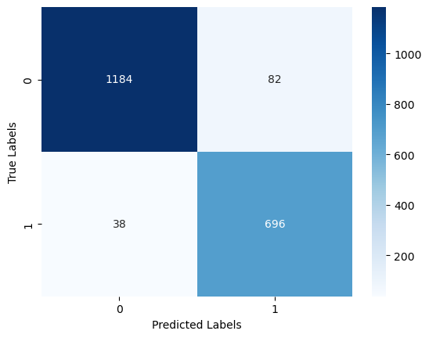

In [ ]:

1

In [83]:

1

(TP) 696 - The model correctly predicted that 696 instances belong to class 1 (positive).

2

(TN) 1184 - The model correctly predicted that 1184 instances belong to class 0 (negative).

3

(FP)82 - The model incorrectly predicted that 82 instances belong to class 1.

4

(FN) 38 - The model incorrectly predicted that 38 instances belong to class 0.

In [83]:

1

*#D3. Provide the code used to perform the classification analysis from part D2.*

In [ ]:

1

med_data.to_csv('MSDA209_PA_task1_D2.cvs')

# **Part V: Data Summary and Implications**

In [ ]:

1

*#E1.Explain the accuracy and the area under the curve (AUC) of your classification model.*

Based on the provided code, the model demonstrates an accuracy of 94% on the test set. Additionally, the Area Under the Curve (AUC) is calculated to be 0.9417, a value near 1. This suggests strong overall performance across various threshold values, affirming the model's ability to effectively distinguish between positive and negative instances.

In [84]:

1

*# Calculating accuracy*

2

accuracy **=** accuracy_score(y_test, y_pred)

3

print(f'Accuracy: {accuracy:.4f}')

4

Accuracy: 0.9400

In [85]:

1

2

*# Classification Report*

3

classification_rep **=** classification_report(y_test, y_pred)

4

print('\nClassification Report:')

5

print(classification_rep)

Classification Report:  
 precision recall f1-score support  
  
 0 0.97 0.94 0.95 1266  
 1 0.89 0.95 0.92 734  
  
 accuracy 0.94 2000  
 macro avg 0.93 0.94 0.94 2000  
weighted avg 0.94 0.94 0.94 2000

In [86]:

1

2

*# Calculating AUC*

3

accuracy_new **=** metrics.roc_auc_score(y_test, y_pred)

4

print(f'AUC: {accuracy_new:.4f}')

AUC: 0.9417

In [88]:

1

fpr, tpr, _ **=** roc_curve(y_test, y_pred)

2

roc_auc_new **=** auc(fpr, tpr)

In [89]:

1

*# Ploting ROC curve*

2

plt.figure()

3

plt.plot(fpr, tpr, label**=**'ROC curve (area = %0.2f)' **%** roc_auc_new)

4

plt.plot([0, 1], [0, 1], 'k--')

5

plt.xlabel('False Positive Rate')

6

plt.ylabel('True Positive Rate')

7

plt.title('ROC Curve')

8

plt.legend(loc**=**"lower right")

9

plt.show()

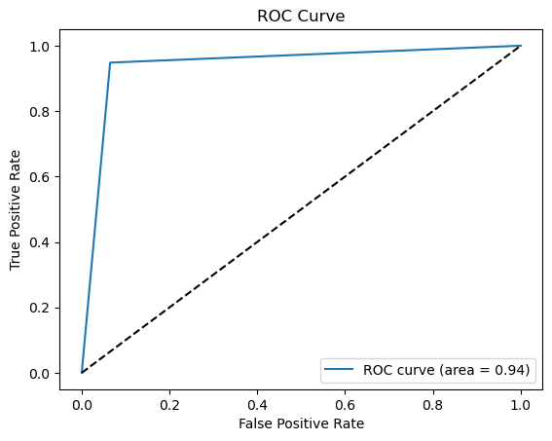

In [ ]:

1

*#E2. Discuss the results and implications of your classification analysis.*

The model demonstrates high accuracy (94.825%) in a cross-validated setting for predicting patient readmission based on chronic conditions, lifestyle factors, and healthcare services a patient receives. The examination of the classification report further explains the model's notable achievements in terms of high precision, recall, and F1-score. Additionally, the analysis includes the computation of the Area Under the Curve (AUC), a metric ranging from 0 to 1. The calculated AUC of 0.9417, nearing the upper limit, signifies superior model performance. This proximity to 1 implies that the model demonstrates a robust true positive rate and maintains a low false positive rate across diverse threshold settings, highlighting its effectiveness in distinguishing between positive and negative instances.

In [ ]:

1

*#E3.Discuss one limitation of your data analysis.*

One possible limitation for the model is data quality and bias. The model's performance heavily relies on the quality

and representativeness of the training data. If the data used for training is biased or incomplete, the model may

inherit these biases and make inaccurate predictions, especially in underrepresented groups. Another limitation is

that the analysis relies on a dataset of 10,000 patients, which might be inadequate for making precise outcome

predictions.

In [ ]:

1

*#E4.Recommend a course of action for the real-world organizational situation from part A1 based on your results and implications discussed in part E2.*

2

3

First, I recommend that the health organization implement the KNN classification model into their system to predict patient readmission based on chronic conditions, lifestyle factors, and healthcare services. This model, with a best-performing parameter of 5 neighbors, has demonstrated high accuracy (94.825%) in a cross-validated setting.

Second, establish a system for continuous monitoring and evaluation of the model's performance. Regularly assess its accuracy, precision, recall, and other relevant metrics to ensure its effectiveness over time.

lastly, collaborate with healthcare professionals to integrate the predictive model into the existing healthcare workflow. This could involve incorporating the model's predictions into decision-making processes related to patient care and resource allocation.

1

*#F* [*https://wgu.hosted.panopto.com/Panopto/Pages/Viewer.aspx?id=d4858191-1934-4991-89ea-b0f8013dfd9e*](https://wgu.hosted.panopto.com/Panopto/Pages/Viewer.aspx?id=d4858191-1934-4991-89ea-b0f8013dfd9e)

#G Statology. (n.d.). How to Plot an ROC Curve in Python. Retrieved from <https://www.statology.org/plot-roc-curve-python/>

Statology. (n.d.). How to Calculate AUC in Python. Retrieved from <https://www.statology.org/auc-in-python/>

W3Schools. (n.d.). Python - Machine Learning - Standardize Data. Retrieved from <https://www.w3schools.com/python/python_ml_scale.asp>

Pulagam, S. (2020, June 6). How to detect and deal with Multicollinearity. Medium. <https://towardsdatascience.com/how-to-detect-and-deal-with-multicollinearity-9e02b18695f1>

Raj, R. (2022, March 16). Classification Algorithms in Python. Thrive in AI. <https://medium.com/thrive-in-ai/classification-algorithms-in-python-5f58a7a27b88>